**Software Requirements Specification**

**for**

**CAT MATHS**

**Version 1**

**Prepared by Team 1 of Software Engineering Concepts Class**

**California State University, San Bernardino**

**Contents**

1. [**Introduction**](https://docs.google.com/document/d/1Z0f3G66ktjPd5w3scrHqGQGpUeXAgPrn-NT0akg0-Mc/edit#heading=h.gjdgxs) **4**

[1.1 Purpose . . . . . . . . . . . . . . . . . . . . . . . . . . . . . . . . . . . . . .](https://docs.google.com/document/d/1Z0f3G66ktjPd5w3scrHqGQGpUeXAgPrn-NT0akg0-Mc/edit#heading=h.30j0zll) 4

1.2 Document Conventions [. . . . . . . . . . . . . . . . . . . . . . . . . . . . . . . . . . . . . . .](https://docs.google.com/document/d/1Z0f3G66ktjPd5w3scrHqGQGpUeXAgPrn-NT0akg0-Mc/edit#heading=h.1fob9te) 4

1.3 Intended Audience & Reading Suggestions  [. . . . . . . . . . . . . . . . . . . . . . . . . . . . . . . . .](https://docs.google.com/document/d/1Z0f3G66ktjPd5w3scrHqGQGpUeXAgPrn-NT0akg0-Mc/edit#heading=h.1fob9te) . 4

1.4 Product Scope [. . . . . . . . . . . . . . . . . . . . . . . . . . . . . . . . . . . . . .](https://docs.google.com/document/d/1Z0f3G66ktjPd5w3scrHqGQGpUeXAgPrn-NT0akg0-Mc/edit#heading=h.30j0zll) 4

1.5 References [. . . . . . . . . . . . . . . . . . . . . . . . . . . . . . . . . . . . . .](https://docs.google.com/document/d/1Z0f3G66ktjPd5w3scrHqGQGpUeXAgPrn-NT0akg0-Mc/edit#heading=h.30j0zll) 4

1. [**Overall Description**](https://docs.google.com/document/d/1Z0f3G66ktjPd5w3scrHqGQGpUeXAgPrn-NT0akg0-Mc/edit#heading=h.3znysh7) **5**

2.1 Product Perspective [. . . . . . . . . . . . . . . . . . . . . . . . . . . . . . . .](https://docs.google.com/document/d/1Z0f3G66ktjPd5w3scrHqGQGpUeXAgPrn-NT0akg0-Mc/edit#heading=h.2et92p0) 5

2.2 Product Functions [. . . . . . . . . . . . . . . . . . . . . . . . . . . . .](https://docs.google.com/document/d/1Z0f3G66ktjPd5w3scrHqGQGpUeXAgPrn-NT0akg0-Mc/edit#heading=h.tyjcwt) 5

2.3 User Classes and Characteristics [. . . . . . . . . . . . . . . . . . . . . . . . . . . . . . . . . . . . . .](https://docs.google.com/document/d/1Z0f3G66ktjPd5w3scrHqGQGpUeXAgPrn-NT0akg0-Mc/edit#heading=h.30j0zll) 6

2.4 Operating Environment [. . . . . . . . . . . . . . . . . . . . . . . . . . . . . . . .](https://docs.google.com/document/d/1Z0f3G66ktjPd5w3scrHqGQGpUeXAgPrn-NT0akg0-Mc/edit#heading=h.2et92p0) 6

2.5 Design and Implementation Constraints [. . . . . . . . . . . . . . . . . . . . . . . . . . . .](https://docs.google.com/document/d/1Z0f3G66ktjPd5w3scrHqGQGpUeXAgPrn-NT0akg0-Mc/edit#heading=h.2et92p0)  6 2.6 User Documentation [. . . . . . . . . . . . . . . . . . . . . . . . . . . . . .](https://docs.google.com/document/d/1Z0f3G66ktjPd5w3scrHqGQGpUeXAgPrn-NT0akg0-Mc/edit#heading=h.2et92p0)  6

2.7 Assumptions and Dependencies [. . . . . . . . . . . . . . . . . . . . . . . . . . . .](https://docs.google.com/document/d/1Z0f3G66ktjPd5w3scrHqGQGpUeXAgPrn-NT0akg0-Mc/edit#heading=h.2et92p0) 6

**3 External Interface Requirements 7**

3.1 User Interfaces (Screens) [. . . . . . . . . . . . . . . . . . . . . . . . . . . . . . .](https://docs.google.com/document/d/1Z0f3G66ktjPd5w3scrHqGQGpUeXAgPrn-NT0akg0-Mc/edit#heading=h.2et92p0)  **7**

3.2 Hardware Interfaces [. . . . . . . . . . . . . . . . . . . . . . . . . . . . . . .](https://docs.google.com/document/d/1Z0f3G66ktjPd5w3scrHqGQGpUeXAgPrn-NT0akg0-Mc/edit#heading=h.2et92p0)  8

3.3 Software Interfaces [. . . . . . . . . . . . . . . . . . . . . . . . . . . . . . .](https://docs.google.com/document/d/1Z0f3G66ktjPd5w3scrHqGQGpUeXAgPrn-NT0akg0-Mc/edit#heading=h.2et92p0)  8

3.4 Communication Interfaces [. . . . . . . . . . . . . . . . . . . . . . . . . . . . . . .](https://docs.google.com/document/d/1Z0f3G66ktjPd5w3scrHqGQGpUeXAgPrn-NT0akg0-Mc/edit#heading=h.2et92p0)  9

### **4 System Features 9**

### 4.1 Starting Screen [. . . . . . . . . . . . . . . . . . . . . . . . . . . . . . .](https://docs.google.com/document/d/1Z0f3G66ktjPd5w3scrHqGQGpUeXAgPrn-NT0akg0-Mc/edit#heading=h.2et92p0) 9

4.2 Main Game Screen [. . . . . . . . . . . . . . . . . . . . . . . . . . . . . . .](https://docs.google.com/document/d/1Z0f3G66ktjPd5w3scrHqGQGpUeXAgPrn-NT0akg0-Mc/edit#heading=h.2et92p0)  10

4.3 Answering [. . . . . . . . . . . . . . . . . . . . . . . . . . . . . . .](https://docs.google.com/document/d/1Z0f3G66ktjPd5w3scrHqGQGpUeXAgPrn-NT0akg0-Mc/edit#heading=h.2et92p0)  10

4.4 Ending Screen [. . . . . . . . . . . . . . . . . . . . . . . . . . . . . . .](https://docs.google.com/document/d/1Z0f3G66ktjPd5w3scrHqGQGpUeXAgPrn-NT0akg0-Mc/edit#heading=h.2et92p0)  10

**5**  **Other Nonfunctional Requirements 11**

5.1 Performance Requirements [. . . . . . . . . . . . . . . . . . . . . . . . . . . . . . .](https://docs.google.com/document/d/1Z0f3G66ktjPd5w3scrHqGQGpUeXAgPrn-NT0akg0-Mc/edit#heading=h.2et92p0)  11

5.2 Safety Requirement [. . . . . . . . . . . . . . . . . . . . . . . . . . . . . . .](https://docs.google.com/document/d/1Z0f3G66ktjPd5w3scrHqGQGpUeXAgPrn-NT0akg0-Mc/edit#heading=h.2et92p0)  11

5.3 Security Requirements [. . . . . . . . . . . . . . . . . . . . . . . . . . . . . . .](https://docs.google.com/document/d/1Z0f3G66ktjPd5w3scrHqGQGpUeXAgPrn-NT0akg0-Mc/edit#heading=h.2et92p0)  12

5.4 Software Quality Attributes [. . . . . . . . . . . . . . . . . . . . . . . . . . . . . . .](https://docs.google.com/document/d/1Z0f3G66ktjPd5w3scrHqGQGpUeXAgPrn-NT0akg0-Mc/edit#heading=h.2et92p0)  12

5.5 Business rules [. . . . . . . . . . . . . . . . . . . . . . . . . . . . . . .](https://docs.google.com/document/d/1Z0f3G66ktjPd5w3scrHqGQGpUeXAgPrn-NT0akg0-Mc/edit#heading=h.2et92p0)  12

**6 Other Requirements 12**

6.1 Storage Solution  [. . . . . . . . . . . . . . . . . . . . . . . . . . . . . . .](https://docs.google.com/document/d/1Z0f3G66ktjPd5w3scrHqGQGpUeXAgPrn-NT0akg0-Mc/edit#heading=h.2et92p0)  12

6.2 Design  [. . . . . . . . . . . . . . . . . . . . . . . . . . . . . . .](https://docs.google.com/document/d/1Z0f3G66ktjPd5w3scrHqGQGpUeXAgPrn-NT0akg0-Mc/edit#heading=h.2et92p0)  12

6.3 Task  [. . . . . . . . . . . . . . . . . . . . . . . . . . . . . . .](https://docs.google.com/document/d/1Z0f3G66ktjPd5w3scrHqGQGpUeXAgPrn-NT0akg0-Mc/edit#heading=h.2et92p0)  12

6.4 Cohesiveness [. . . . . . . . . . . . . . . . . . . . . . . . . . . . . . .](https://docs.google.com/document/d/1Z0f3G66ktjPd5w3scrHqGQGpUeXAgPrn-NT0akg0-Mc/edit#heading=h.2et92p0)  13

**1. INTRODUCTION**

### **1.1 Purpose**

This document outlines the software requirements specifications for a mobile math game app that teaches addition to children ages 6-9. The goal of this SRS is to capture requirements for key app features and functionality to guide development of the system.

### **1.2 Document Conventions**

This SRS follows a standard template structure with numbered sections and subsections. Requirements are written in clear language aimed at the technical and non-technical stakeholders involved in the project. Screenshots and diagrams are included where relevant to illustrate requirements.

### **1.3 Intended Audience and Reading Suggestions**

The key intended audiences for this document are developers, QA testers, product managers, and designers involved in building the system. It is recommended that all audiences first read the Overall Description and System Features sections for a high-level understanding before consulting specific requirements details.

### **1.4 Product Scope**

The scope of this release focuses on core mathematical gameplay and mechanics for addition problems aimed at early elementary grade levels. Advanced features like customization, social sharing, analytics etc. are considered out of scope.

### **1.5 References**

* **Software Engineering: A Practitioner's Approach**

**https://ebookcentral.proquest.com/lib/csusb/detail.action?docID=6328275&pq- origsite=primo**

* **ChatGPT https://chat.openai.com/auth/login**
* **ChatUml https://chatuml.com/edit/new**

**2. Overall Description**

**2.1 Product Perspective**

The game aims to closely replicate the popular children's math app found on the Play Store, with its main objective being to gamify the learning of addition through the use of cat animation, making it both easier to grasp and more entertaining for kids to learn.

# **2.2 Product Functions**

The game aims to assist children in learning basic addition through a range of games with varying difficulty levels. High-quality cartoon animations and sounds are incorporated strategically to enhance both learning and enjoyment. Below is a summary of the game's key features implemented.

They are separated into categories depending on their function:

* **Title / Menu screen**: The first screen users encounter upon opening the application displays buttons for both gameplay and settings.
* **Cat character**: A cat character animation has been designed to actively engage children within the application.
* **Generating random numbers and validating them:** Various numbers are generated along with the correct answers for the give addition game question.
* **Generate questions and validate the answers with reactions:** The addition questions are accompanied by cat animations, displaying a happy emoji for correct answers and a sad emoji for incorrect ones.
* **Generating sound for question:** For each question, sound effects accompany the prompt, with correct answers receiving positive feedback and incorrect ones receiving none.
* **Kids learning progress monitoring:** Upon completing each level, it displays the accuracy rate, number of correct answers, incorrect answers and Rate allowing for easy tracking of progress.

# 

# **2.3 User Classes and Characteristics**

The game's controls are easy to understand, and the gameplay is fair for everyone, so it won't make a big difference in who plays it. But like any game, there are different types of players: some who play a lot and some who just play sometimes. In this game, the ones who play a lot are kids in primary school.

# **2.4 Operating Environment**

This application will be launched on both the Play Store (Android) and App Store (iOS). A web- based platform is not currently intended.

# **2.5 Design and Implementation Constraints**

The CAT MATHS ADD game app for kids is a very minimalistic app both in its functionality and user experience. As of now, there are no constraints that are noticed by the developers.

# **2.6 User documentation**

This app is straightforward and basic, users won't encounter significant challenges. We have not implemented any complex operations that pose compatibility issues. Children who are just beginning their learning journey can easily use the app without any trouble.

# **2.7 Assumptions and Dependencies**

We'll employ Unity 2D for graphics in this project. Once testing is complete, we'll determine the minimum requirements and the earliest version of Android to support before launching the game on the market. Currently, there don't seem to be any dependencies for this app, as it's standalone and doesn't involve any complex operations.

**3. External Interface Requirements**

This section of the SRS outlines the specifications for the system's interface, covering user, hardware, software, and communication requirements.

**3.1 User Interfaces**

**3.1.1 Main Screen/Home Screen:**

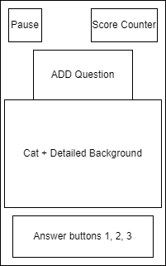

**Figure 01:** Initial loading screen for the CAT MATHS

**3.1.2 Gameplay:**

For every new question generated a new monster appears after successfull 5 correct answers boss monster appears indicating last chance for winning or losing a game.

**3.1.3 Game over:**

Whenever an appropriate task is incomplete, the game over-screen will appear and prompt the user to continue the game.

**3.1.3.1 Invoke restart level.**

When invoked, the current game level restarts.

**3.1.3.2 Invoke Home menu.**

When invoked, the game returns to home menu screen.

**3.1.4. Level Complete**

Level completed for CAT MATHS.

**3.1.4.1 Invoke Restart Level**

When invoked, the current game level restarts.

**3.1.4.2 Invoke home menu.**

When clicked the game returns to home screen.

**3.2 Hardware Interfaces**

The Math Kid Game for Kids’ mobile app may interact with the following hardware interfaces

**3.2.1 Touchscreen Interface**

**Description**: The app relies on the device's touchscreen interface for user interactions, such as tapping buttons, entering answers, and navigating menus.

**Functionality**: The app should respond to touchscreen gestures, including taps, swipes, and multi-touch interactions.

**3.2.2 Speaker and Audio Interface**

**Description**: The app uses the device's speaker and audio interface to provide audio

feedback, including sounds, music, and spoken instructions.

**Functionality**: The app should play audio cues, instructions, and background music through the device's speaker.

**3.3 Software Interfaces**

**3.3.1 Unity**

The application will use the Unity game engine for the user interface of the connectome application. While the application will not contain any game components, the framework makes the interface with the Math Kid Game easy. A 32-bit personal version of the Unity game engine is used for the project. None of the components of the professional version should be needed for the application. Unity version 5.5 is used for the development of the project.

**3.3.2 VisualStudio**

A streamlined code editor, Visual Studio Code supports development activities like task execution, debugging, and version management. It seeks to offer only the tools a developer needs for a brief code-build-debug cycle and leaves more complicated processes to IDEs with more features, like Visual Studio IDE.

**3.3.3 AzureDevOps**

Azure DevOps, created by Microsoft, is an extensive collection of development tools and services designed to oversee the complete software development lifecycle. It encompasses capabilities for source code management, build automation, continuous integration and delivery (CI/CD), project tracking, and other functionalities. Azure DevOps facilitates efficient team collaboration, leading to the delivery of high-quality software products.

**3.3.4 AzureFunctions**

Azure Functions is a serverless solution that enables you to write minimal code, reduce infrastructure management, and cut costs. Rather than dealing with server deployment and maintenance, the cloud infrastructure automatically supplies the necessary resources to keep your applications operational.

**3.3.5 VisualStudioAppCenter**

Visual Studio App Center is a cloud-based service designed to offer developers a toolkit for building, testing, distributing, and monitoring applications across multiple platforms, including iOS, Android, Windows, macOS, React Native, and Xamarin.

**3.4 Communications Interfaces**

No interface requirements are necessary as there is no need for network activity.

**4.System Features**

**4.1 Title/Menu Screen**

**4.1.1 Description and Priority**

The title screen serves as the initial interface where players can choose to start the game or modify options. As the central hub for all project activities, the home/menu screen is essential and should be incorporated.

**4.1.2 Stimulus/Response Sequences**

**Step 1:** Players will initiate the game from their portable devices.

**Step 2:** Upon loading, the start screen prompts the player to begin the game. In the

third step, the player presses the button, initiating the actual gameplay.

**4.1.3 Functional Requirements:**

**RFQ-1:** The home/menu screen must load and appear every time the game

M4.2 4.2.1 is launched.

**RFQ-2:** If the player quits the game during any stage of a level, they must be returned

to main screen

**RFQ-3:** If the player presses the exit button, the game will end.

**RFQ-4:** If the player completes the game, it will take them to the Level complete

screen and then the player can replay the game or go to the home screen.

**4.2 Generate random numbers and validate the answers.**

**4.3.1 Description and Priority:**

Upon reaching the Adding Puzzle screen from the menu, players encounter addition questions. They must choose the correct answer and drag it to the appropriate location. A correct response triggers a cat animation, confirming accuracy. If the answer is incorrect, the player receives a prompt notifying them of the mistake.

**4.2.2 Stimulus/Response Sequences:**

**Step 1:** The player navigates to the gameplay screen from the main screen.

**Step 2:** On the screen, we can see a cat, and monster, and some random numbers

along with accurate numbers for response.

**Step 3:** An addition question will be generated with random numbers and

displayed on the screen.

**Step 4:** In the answer board random numbers are generated, including the correct

answer.

**Step 5:** Once the answer is selected from the board, a cat animation will pop up

acting as to whether the answer is correct or incorrect.

**4.2.3 Functional Requirements:**

**RFQ-1:** The cat should appear on the screen and indicate the answer is correct if the

player selects the correct answer from the random numbers.

**RFQ-2:** When the player chooses the correct answer, a cat animation needs to be

played.

**RFQ-3:** When the player chooses the wrong response, it should indicate the answer is

incorrect.

**RFQ-4:** By clicking on the pause menu window button displayed at the top left corner, the

Player can go back to the screen and choose the game options like back to the home

screen.

### 

### **5. Other Nonfunctional Requirements**

### **5.1 Performance Requirements**

The app should provide a smooth, responsive user experience. Response times for answering questions and navigation interactions should be under 500ms to avoid any perception of lag. Animations and transitions between screens should maintain a minimum frame rate of 60fps for seamless visual feedback. The app launch process itself should take no longer than 5 seconds. Performance should be optimized to consume minimal device battery and memory resources, avoiding excessive CPU usage or power draw.

### 

### **5.2 Safety Requirements**

As a child-focused educational app, safety is paramount. No dangerous, inappropriate, or mature content should be present. External ads, links, or other content from unverified sources must be avoided. The app should adhere to all applicable app store guidelines for child appropriate content ratings. Math questions and concepts must be age-appropriate and non-violent.

### 

### **5.3 Security Requirements**

User data privacy and security is important, especially for an app aimed at children. Network transmission of any user data or telemetry must be encrypted. Any user identifiers, scores, or other stored data should be properly secured via access controls. No personally identifiable information should be collected or transmitted without clear disclosure and consent.

### 

### **5.4 Software Quality Attributes**

The app should deliver an intuitive, easy to use interface following established mobile conventions and optimized for simplicity. Visual design should be friendly, engaging, and appropriate for the target age group. Mathematical logic must be accurate and

calculations precise reflecting valid addition fundamentals. Support for accessibility features like text-to-speech could aid usage for those with disabilities.

### 

### **5.5 Business Rules**

N/A

### **6. Other Requirements**

### **6.1 Storage Solution**

User profile data including usernames, scores, and progress will be stored in a NoSQL cloud database like MongoDB. Game question data can be stored in a JSON file bundled with the app package. Any media assets can be stored in object storage such as AWS S3.

### **6.2 Design**

The app design should follow Google's Material Design principles optimized for mobile. It should use a simple, intuitive navigational paradigm common to other educational apps. The visual style should be bright, fun, and engaging for kids.

### **6.3 Task**

Key tasks the app needs to support include:

* Registering a user profile
* Selecting a game mode or difficulty level
* Displaying and answering math questions
* Scoring gameplay and storing results
* Providing feedback on answers
* Pausing and resuming gameplay

All core gameplay functionality should provide clear calls-to-action, feedback, and transitions between tasks.

### **6.4 Cohesiveness**

The app should provide a cohesive user experience with consistent UI/UX design patterns and standardized visual styles. Interactions should be intuitive with clear response to user input. Terminology should be simple and concise. Components like colors, fonts, icons should all align to a unified aesthetic style.

# 7. **Appendix: Analysis Models**

1. **UML Use Case Diagram**

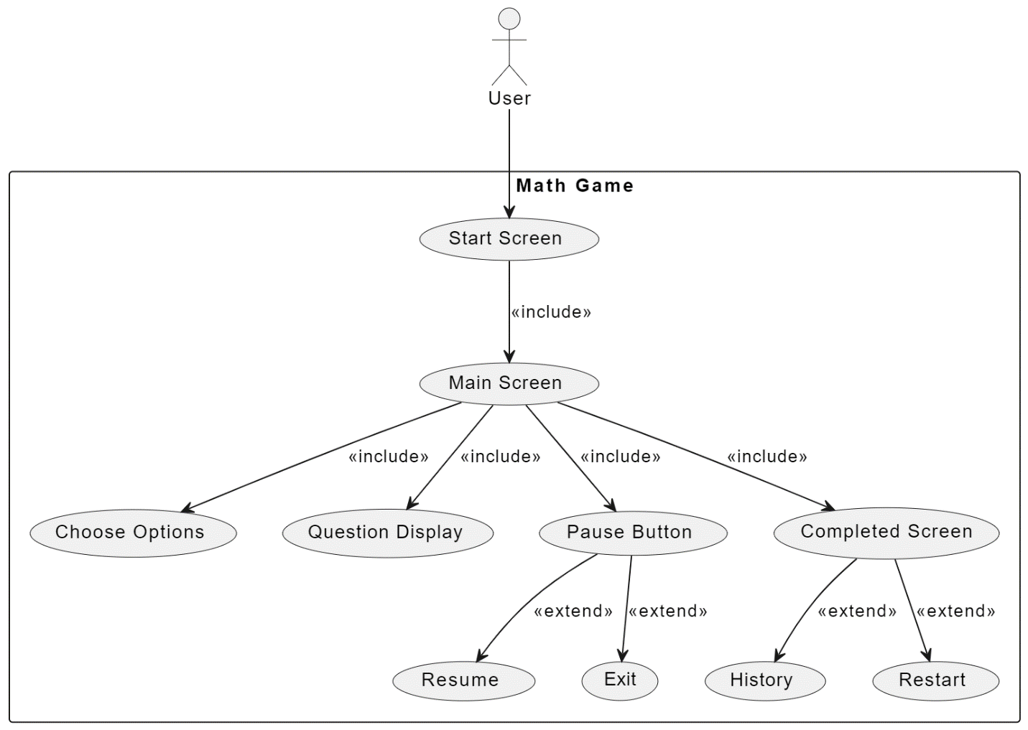

1. **UML Class Diagram**

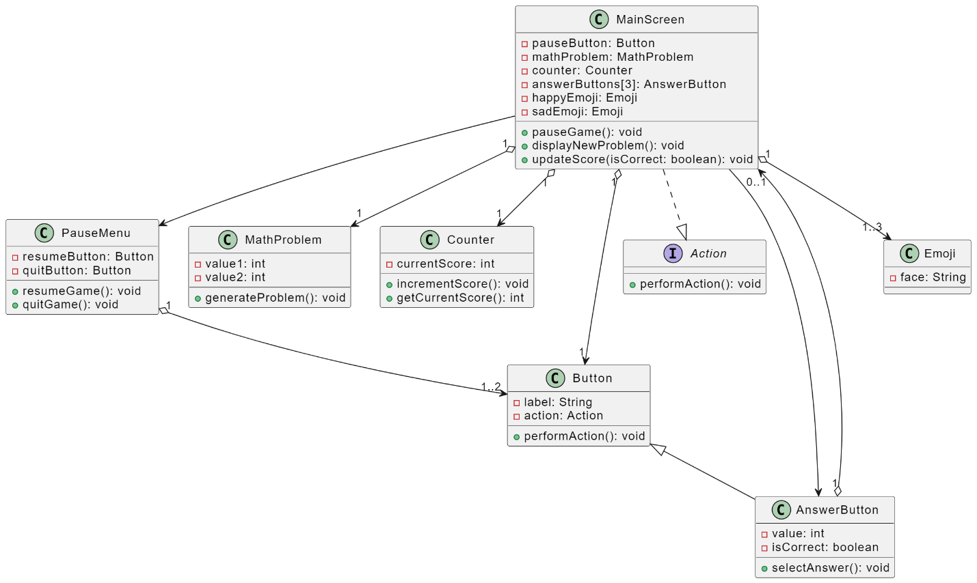

1. **UML Sequence Diagram**

